EXP 4: Create a simple cloud software application for Car Booking Reservation System using any Cloud Service Provider to demonstrate SaaS.

Aim
To develop a cloud-based SaaS car booking system that allows users to reserve vehicles online using cloud services like Amazon Web Services or Google Cloud Platform.

Algorithm
Algorithm: Car Reservation System
- Start
- User login/register
- Display available cars
- User selects car + date/time
- Check availability
- If available → confirm booking
- Store booking in cloud database
- Generate booking ID
- Send confirmation notification
- End

Procedure
- Select Cloud Platform
  - Amazon Web Services / Microsoft Azure
- Frontend Development
  - UI for car listing, booking form
  - Technologies: HTML, CSS, JS
- Backend Development
  - Node.js / Java / Python
  - APIs for booking and availability
- Database Setup
  - Cloud database (Firebase / AWS RDS)
  - Store cars, users, bookings
- Deployment
  - Host on AWS EC2 / Azure App Service
- SaaS Implementation
  - Multiple users access
  - Subscription model or usage-based billing
- Testing
  - Validate booking conflicts
  - Ensure real-time availability

OUTPUT:
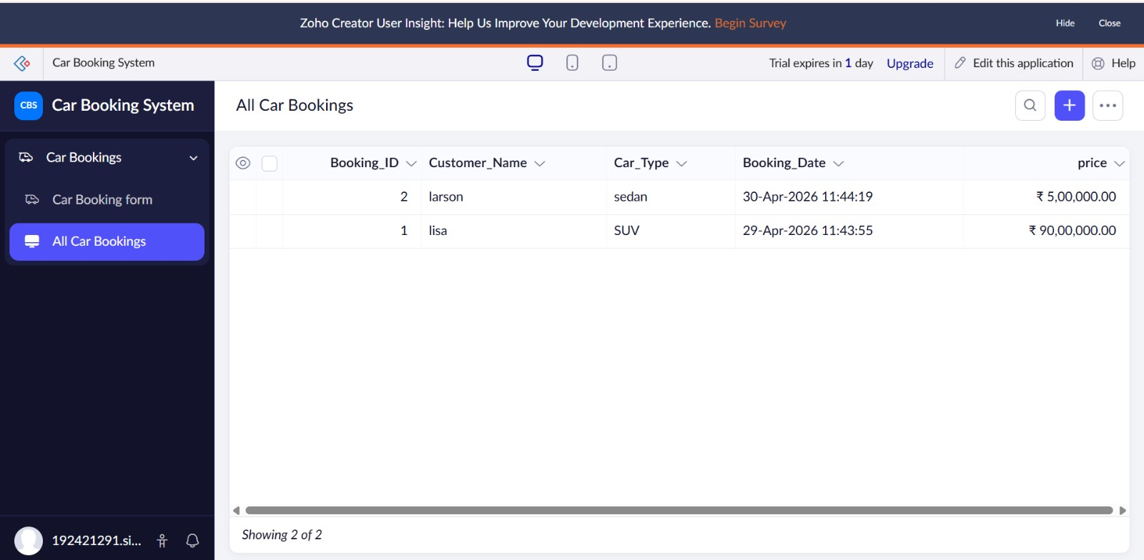
Result
A cloud-based SaaS car reservation system is implemented where users can:
- View available cars
- Book vehicles online
- Access system from anywhere

